# List of Materials to Submit for Pre-launch page

|  |
| --- |
| * **Please provide all materials mentioned in #1-3(A-E)** * **The production of a pre-launch page will only include ONE page. All links you find in the page should be either externals links, or links to a file.** |

1. **Make sure you have added your show to our company's calendar's list** ([**http://www.adsale.com.hk/web/Exhibition/lang-eng/show_calendar.aspx**](http://www.adsale.com.hk/web/Exhibition/lang-eng/show_calendar.aspx)).   
   You may contact Emma Leung (HKO-PR) for assistance.
   * This step is required if you need to create the standard enquiry form in adsale.com.hk. Please click here for example
   * Since enquiry form and pre-reg form are developed during full / mobile website creation, they are not available during pre-launch page creation. If you wish to add a form in the pre-launch page to collect data, you can link to the standard enquiry form in adsale.com.hk.
2. **Key Art, MasterAd, Poster, Leaflet, Brochure, Theme Color or other graphics that we can use to design the layout** (*preferably AI file)
3. **Provide the information below.**

#### Basic Information

|  |  |  |  |
| --- | --- | --- | --- |
|  | **EN** | **TC** | **SC** |
| Show Name |  |  |  |
| Venue |  |  |  |
| Date |  |  |  |

#### Theme Color

Please use color based on the MasterAd provided by user.

OR

I would like to specify a theme color: Click to enter your color here.

#### Buttons (max. 8)

Identify the links to be included in the pre-launch page (*see below example).  
They can only be an external link or a link to a file that we can upload to the domain.

|  |  |  |  |  |  |
| --- | --- | --- | --- | --- | --- |
|  | **Type** | **EN** | **TC** | **SC** | **Link / File** |
| 1 | Button |  |  |  |  |
| 2 | Button |  |  |  |  |
| 3 | Button |  |  |  |  |
| 4 | Button |  |  |  |  |
| 5 | Button |  |  |  |  |
| 6 | Button |  |  |  |  |
| 7 | Button |  |  |  |  |
| 8 | Button |  |  |  |  |

#### Social Media (if any)

Below highlighted in YELLOW are examples.

Please also advise the display sequence in column “Display Sequence”

|  |  |  |  |  |  |
| --- | --- | --- | --- | --- | --- |
| **Display Sequence** | | | **Media** | **ID / Name** | **Link / QR code** |
| **EN** | **TC** | **SC** |
|  |  |  | Facebook | yiwutex | facebook.com/yiwutex |
|  |  |  | LinkedIn | yiwutex | hk.linkedin.com/in/yiwutex |
|  |  |  | Twitter | PrintingSChina | twitter.com/PrintingSChina |
|  |  |  | Weibo | @yiwutexandsewing |  |
|  |  |  | Weixin (WeChat) | YiwuTex | Please provide the QR code for WeChat |

#### Other Content (if any)

|  |  |  |
| --- | --- | --- |
| **EN** | **TC** | **SC** |
|  |  |  |

# Example of Layout

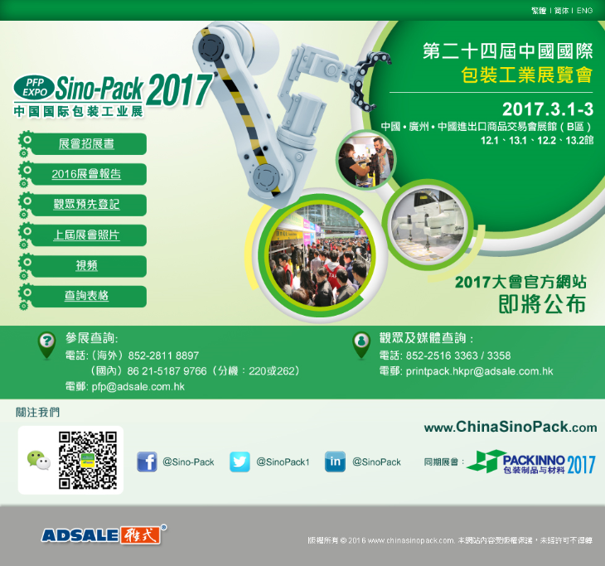

**1**  
Enquiry Form in adsale.com.hk

**2 & 3B**

[Key Art / Theme Color](#Theme Color)

**3C**  
[Buttons](#Buttons (max. 8))

**3E**  
[Other Content](#Other Content (if any))

**3D**  
[Social Media](#Social Media (if any))

**3A**  
[Basic Information](#Basic Information)

# Example of Enquiry Form

|  |  |
| --- | --- |
| <https://www.adsale.com.hk/web/Exhibition/lang-trad/enqform.aspx?exhid=474>   * You will be able to generate report at the reports system. * An email notification will be sent out to the team email according to the box being checked. * The data collected is stored in a different system from the pre-reg system. |  |